Q1).
a).
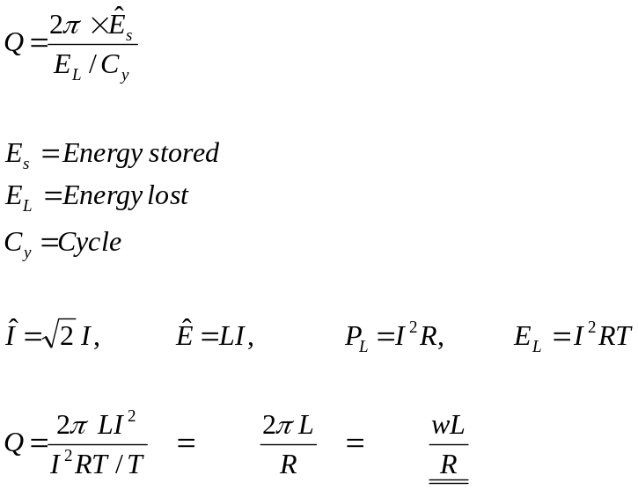

b). A.C. equivalent of Figure 2

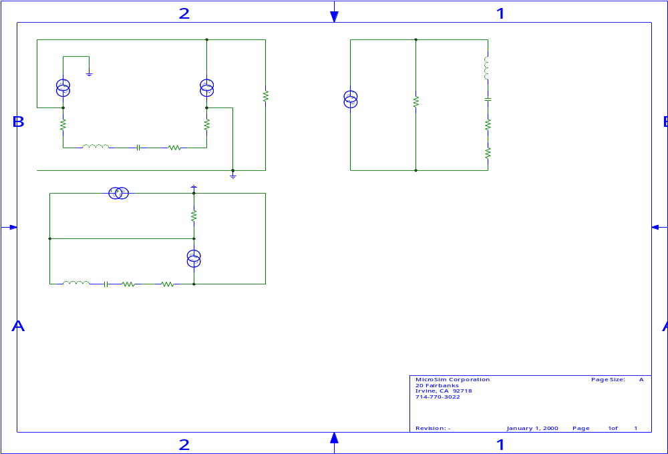
L
C
r
r_{e}
R_{c}
i_{c}
i_{c}
r_{e}

Revised version of the circuit above, because the I_{dc}’s are the same the intrinsic emitter resistance of the emitter follower and common base transistors are the same. Combining them to form one equivalent resistance 2r_{e}.

i_{c}
i_{c}
2r_{e}
R_{c}
r
C
L

From the circuit above it can be seen that the bottom AC current source is shorted. Thus can be eliminated from the analysis. The circuit in its simplest form is shown below:-

i_{c}
2r_{e}
r
C
L
R_{c}
Ignoring the reactive components, notice (r + r_{e}) are in parallel with the collector resistance R_{c}. Hence:-

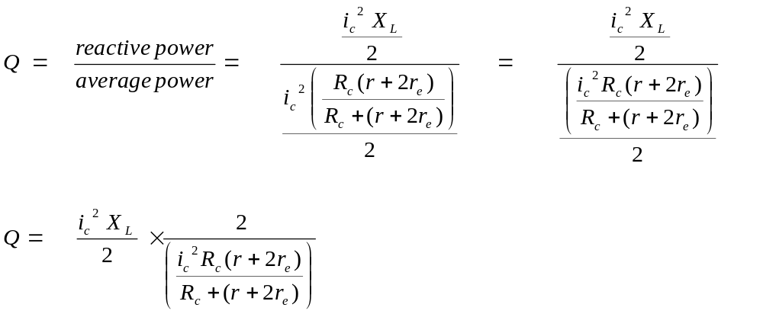

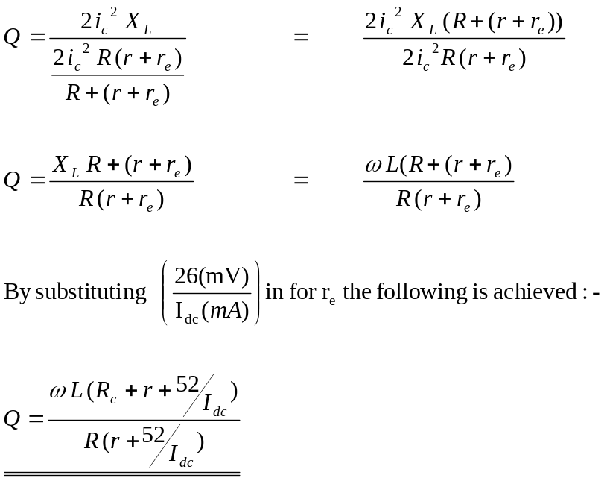

c). In some applications of resonant circuits, it is desirable to minimise the total resistance in the circuit (i.e., to dissipate as little energy as possible). The higher the Q the lower the real power losses within the circuit.

d). Limit the frequency of the source voltage.
In some RLC circuits there is no resistor present, the total resistance is dependant upon the resistance of the inductor (coil) winding. For that reason it is conventional to speak of the “Q of the coil.” In practical coils, there is a upper limit to the value that Q may reach as frequency is increased, due to the property of effective resistance. Because of the magnetic phenomena that occur in conduction at high frequencies, there is an increase in energy loss. This is the same effect as an increase in resistance. At very high frequencies, the increase in effective resistance may become so great that the Q of the coil actually decreases.

